Tutorial to demo functionality

Step 1 : navigate to <https://econtrade.z8.web.core.windows.net/>

Step 2 : The UI will be as follows

Step 3 : Enter the key to tradingeconomics and save

Step 4: The UI will be as follows

Step 5 : Click on “Add Raw Data” The UI will be as follows

Step 6 : Enter the following values

data set => Mexico gdp

Country => Mexico (select from drop down)

Group => gdp (select from drop down)

Click load after a few seconds the following screen with data will show

Step 7 Click on Add Raw data again the following screen will appear

Step 8 for the second data set make the following selection

data set => NZ gdp

Country => New Zealand (select from drop down)

Step 9 :Click on Load NZ gdp data will load

Step 10: Click on Compare Data on the top tool bar . The following form will show

Step 10 : Enter as follows

Replace Comparison1 with Mexico VS NZ

Keep Set Innit Script checked and for the script box below enter the following

Below // if needed add global variables here

Enter

var keyvalues = undefined;

var keyvalueIndex = 0;

inside the function below

//if needed write a script to innitialise data. Do not change function name

Enter

keyvalues = new Object();

keyvalueIndex = 0;

It should look like this, please note the function name will be different

Step 11

In the compare data set input box replace CompareDataSet1 with Mexico

Keep the Filter Rows Check and inside the text area below // write a script to filter out rows and return the filtered dataset. Do not change function name

Enter the following code to filer a data set that does excludes missing values and has units of percent

return ds.filter(gdp => gdp.Unit === 'percent' && gdp.LatestValue && gdp.LatestValue !== '');

Step 12

Next the computation or selection of fields to compare.

Replace fld0 with Key => this field will be computed to have a unique key based on the combination of fields

In the radio selection select Compute field this will open a text area to enter code

Enter the following code below //write code to return field value. Do not change function name

let parts = row.LatestValueDate.split('-');

let key = GetAlphaNumeric(parts[0] + parts[1] + row.Category);

if (!keyvalues[key]) {

keyvalues[key] = ++keyvalueIndex;

}

return keyvalues[key];

It should now look as follows:

Step 13

Replace fld1 with Date Category. Select Compute field in the radio group.

Enter the following code in the text area below

let parts = row.LatestValueDate.split('-');

return parts[0] + parts[1] + ' ' + row.Category;

It should now look as follows

Step 14

Click on Add Field and replace fld2 with GDP. Keep the radio as select a field. In the field select data set fields drop down select LatestValue

It should now look as follows

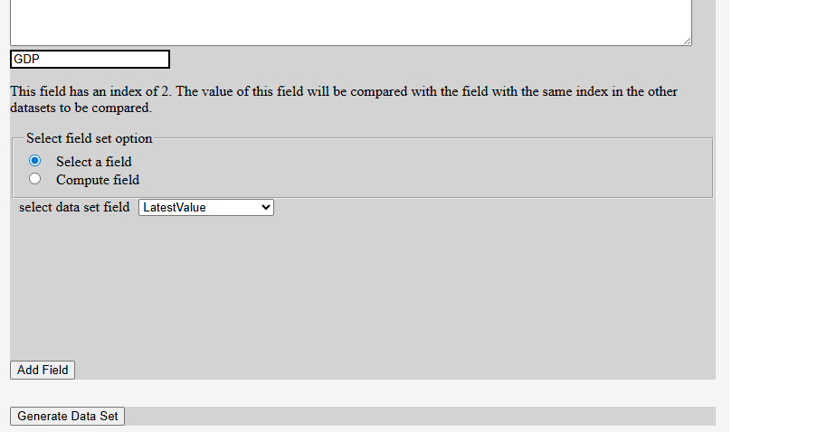

Step 15

Click on Generate Data Set, this will create the DataSet. It will show as follows

Step 16

Repeat steps 11 to step 15 for the data entry section following the above except in step 11

Replace CompareDataSet2 with NZ and select NZ gdp

Once all the data is entered it should look as follows

Step 17 click Generate Data Set for NZ. It will show as follows

Step 18 Click on Generate Comparison on lower left corner it should produce the following Grid comparing Mexico vs NZ data sets generated above

Step 16 In this step a script will be added to generate a bar chart. Click on add run script on lower left corner

In the code area below //Do not change function name

Enter the following code

let obj = new Object();

obj.tagType = "svg";

obj.attributes = new Object();

obj.strokewidth = "1";

var gid = GuidIDStr();

var section = new Object();

section.tagType = "section";

section.attributes = [];

var attr = new Object();

attr.name = 'id';

attr.value = 'section' + gid;

section.attributes.push(attr);

obj.elem = createHtmlElement(section);

// mainElem = document.getElementById("main");

scriptElem.append(obj.elem);

let svgroot = document.getElementById("svgroot");

if (svgroot) {

svgroot.remove();

}

obj.attributes.parentId = gid;

obj.attributes.id = "svgroot";

obj.attributes.version = "2";

obj.attributes.stroke = "black";

obj.attributes.width = "100%";

obj.attributes.height = "450";

createSVGTag(obj);

createGtag();

createXaxis(400, 40, 0, 266, ["1", "2", "3", "4", "5", "6", "7", "8", "9", "10"], 20);

createYaxis(400, 40, 0, 0, getLegendsArray(-1, 2), -30);

let items = compareobj.items;

let maxicoData = [];

let nzData = [];

items.forEach(item => {

let maxObj = new Object();

maxObj.x = item.Mexicokey \* 40;

maxObj.y = item["Mexicogdp"] \* 133;

maxObj.w = 10;

maxObj.xoffset = -10;

maxicoData.push(maxObj);

let nzObj = new Object();

nzObj.x = item.NZkey \* 40;

nzObj.y = item["NZgdp"] \* 133;

nzObj.w = 10;

nzObj.xoffset = 0;

nzData.push(nzObj);

});

barChart(maxicoData, "red");

barChart(nzData, "blue");

let gtagElem = document.getElementById('gtag')

gtagElem.setAttribute("transform", "translate(60,0)");

obj = new Object();

obj.elem = document.getElementById('gtag');

obj.tagType = "rect";

obj.attributes = new Object();

obj.attributes.x = 340;

obj.attributes.y = 40;

obj.attributes.width = 10;

obj.attributes.height = 10;

obj.attributes.fill = "red";

createSVGTag(obj);

createSVGText(380, 45, "Mexico", "gtag")

obj = new Object();

obj.elem = document.getElementById('gtag');

obj.tagType = "rect";

obj.attributes = new Object();

obj.attributes.x = 340;

obj.attributes.y = 25;

obj.attributes.width = 10;

obj.attributes.height = 10;

obj.attributes.fill = "blue";

createSVGTag(obj);

createSVGText(380, 30, "NZ", "gtag");

Click on Run it should result in the following bar chart

